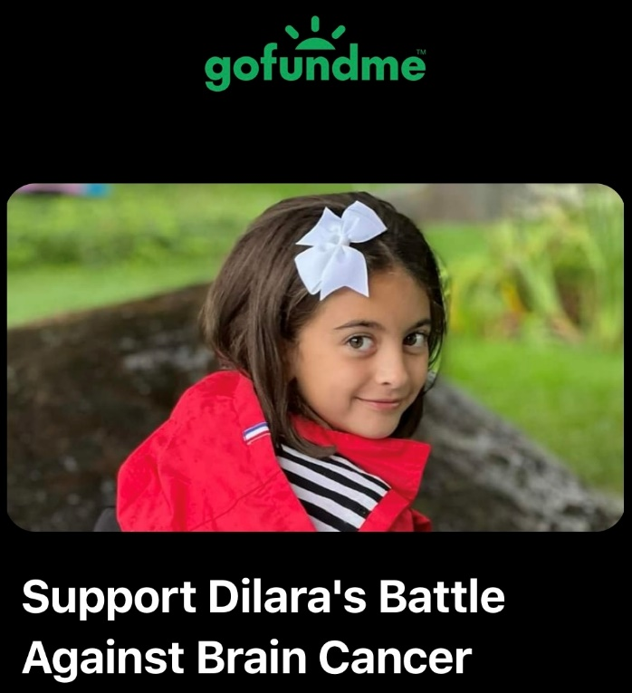
Dilara is literally being faced with the fight of her life
Our friends and family are raising funds for a brave, loving, intelligent and compassionate 9-year-old girl, Dilara Coker. One day Dilara was at gymnastics and started having unusual symptoms such as a tingly nose and chattery teeth; her symptoms progressed into intense episodes over the course of ONE week.
Dilara’s mom, an experienced RN, took her to the hospital on Sat Jan 13th where she underwent multiple blood tests and CT/MRI scans. Within 20 hours of walking through the doors of the Pediatric Emergency Room, Dilara had brain surgery to remove a tumor. YES, it happened that fast!
Unfortunately, only half of the tumor could be removed due to too much bleeding and a high risk of damaging surrounding brain tissue, which would lead to life-long neurological impairments. The doctors said her tumor is a very aggressive, rapidly growing cancer. Thus, beginning Dilara’s battle against brain cancer.
As a result of her surgery Dilara was left with an incision from the front of her forehead all the way around to the tip of her earlobe, plates and screws implanted into her head, weakness in her left arm and leg, and lasting psychological issues. She needs PT and OT, anti-seizure medication and proton radiation therapy in Harlem, NY. She is unable to attend school but is getting tutored. She cannot participate in any previous recreational activities and has a fear of bumping her head or falling. Currently Dilara is at home with her mother Katelyn, father Cenk, baby sister Ceylin, and puppy Mello. All funds will help lessen the burden associated with Dilara's care (medical bills, housing, transportation, basic needs, etc.)
PLEASE HELP THEIR FAMILY STAY ABOVE WATER DURING THE MOST IMPORTANT FIGHT OF THEIR LIVES
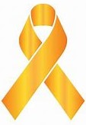
DILARA NEEDS BOTH OF HER PARENTS BY HER SIDE DURING THIS FIGHT

Thank you for donating to our cause, we appreciate all the support and encouragement!

If you can take the time to share this with others, we would greatly appreciate it.
Sharing is one of the best ways to help Dilara.

#dilarasjourney
#sickschool
#childhoodcancerawareness #StonyBrookChildrens
#MSKKids
https://www.gofundme.com/f/support-dilaras-battle-against-brain-cancer


